

WIA1002 DATA STRUCTURE
SmartFood Delivery System

OCC 12 Group 4
Group Project

Name | Student ID
HARRESH A/L SCEAGAN @ SEGARAN | 24053505/2
JANICE LIM PEI YIN | 23120730/2
KOH PEI YIN | 23119212/2
LIM SU ANN | 25059663/1
SRINIVAAS A/L THIRUCH SELVAM | 25073990/1

Lecturer: Dr. Zainab Malik
Team Leader:

1.0 Problem Statement
Food delivery services have become increasingly important in daily life. Managing customer orders manually can lead to delays, errors, and inefficient order processing. Problems such as incorrect order sequences and difficulty tracking processed orders may reduce service quality.
Therefore, this project develops a Food Delivery System using appropriate data structures to improve order management efficiency and provide a systematic process for handling customer orders.

2.0 Objectives
The objectives of this project are:
- To develop a functional food delivery system application.
- To implement data structures in solving real-world problems.
- To process customer orders efficiently using Queue.
- To implement undo functionality using Stack.
- To optimize backend delivery logistics and decrease customer wait times using a customized Min-Heap priority dispatch queue.
- To provide a user-friendly interface for food ordering operations.

3.0 System Features

The Food Delivery System includes the following features:
- Display food menu
- Add food into cart
- Place order
- Process customer orders
- Undo processed orders
- Automated priority rider assignment
- Display order history/rider status log
- Exit system

4.0 Approach / Methodology
The system follows several stages in handling customer orders:
- Customer selects food items.
- Selected items are added into cart.
- Customer confirms the order.
- Order enters the processing queue.
- Orders are processed according to FIFO principle.
- Processed orders are stored in a stack for undo functionality.
- Processed orders trigger the priority dispatch engine to allocate the fastest available rider.

System workflow:
Customer
↓
Food Selection
↓
Shopping Cart
↓
Order Queue (FIFO Queue)
↓
Process Order
↓
Undo Stack (LIFO Stack)
↓
Rider Assignment Queue (Min-Heap Priority Queue)

4.1 Linear Queue for Customer Order Management

This module is responsible for handling customer orders in an organized and efficient manner. Since food delivery systems may receive multiple customer requests continuously, the system must ensure that orders are processed fairly according to the sequence in which they arrive.

The Queue data structure was selected because it follows the First-In-First-Out (FIFO) principle. This behavior matches real-world food ordering situations where customers who place orders earlier should receive service before customers who place orders later.

The implementation consists of the following components:

Order.java: Stores order information including order ID, customer ID, restaurant ID, food items, total price, and order status.

OrderQueue.java: Implements a custom linked-list-based queue structure that manages the flow of customer orders.

Queue Operations: Provides functions such as enqueue(), dequeue(), peek(), and displayQueue() to support order insertion, processing, and monitoring.

4.2 LIFO Stack for State Restoration & Undo Processing
This module provides an undo mechanism during the food ordering process. While selecting items, customers may change their decisions and remove previously added items from the shopping cart. Therefore, a structure capable of efficiently handling such operations is required.

The Stack data structure was selected because it follows the Last-In-First-Out (LIFO) principle. The most recently added item becomes the first item to be removed.

The implementation includes:

- UndoStack.java – Implements a custom linked-list-based stack structure for managing cart items.

Stack Operations – Includes push(), pop(), peek(), and displayCart() functions for item insertion, removal, and display purposes.

This approach improves user experience because customers can quickly undo recent actions without searching through the entire cart.

4.3 Min-Heap for Delivery Rider Assignment

The primary objective of this module is to automate the matching process between an incoming food delivery order and the most optimal delivery rider available. "Optimal" is defined strictly by efficiency: the rider with the lowest estimated trip time must always be selected first to minimize customer wait times.

To achieve this, the module is broken down into three logical layers:

Data Layer (Rider.java): Encapsulates individual rider profiles, tracking unique IDs, names, availability statuses (boolean), and their dynamically updated estimated arrival times.
- Algorithm Engine (MinHeap.java): Implements a completely custom priority queue. Instead of searching linearly through a list of riders when an order comes in, riders are stored in a binary tree structure mapped sequentially inside a dynamic array (ArrayList). The data structure actively re-balances itself during insertions and deletions to guarantee that the fastest rider is always sitting at the root position (index 0).
- Service Coordinator (DeliveryAssignment.java): Acts as the bridge between the data structure and the external application system. It filters out busy or invalid riders and safely handles the assignment processing pipeline.
- 4.4 Graph & Dijkstra's Algorithm for Route Optimization
This module is responsible for finding the shortest delivery route from a restaurant to the customer's address. Real-world road networks consist of multiple junctions and paths with varying distances, making it impractical to manually determine the optimal route. A graph-based approach is therefore necessary.
The Graph data structure was selected to represent the delivery road network, where each node represents a location (restaurant, junction, or customer address) and each weighted edge represents a road segment with its associated distance or travel time.
The implementation consists of the following components:
● Location.java: Represents a single location node with a name identifier.
● Graph.java: Implements an adjacency list using a HashMap to store all routes. Each location maps to a list of neighbouring locations with associated edge weights.
● Dijkstra.java: Implements Dijkstra's shortest path algorithm using a priority queue to efficiently explore the graph and determine the minimum-cost path from source to destination.

- 4.5 BST & HashMap for Food Search and Data Retrieval
This module handles two distinct but complementary responsibilities: fast food item searching and sorting via a Binary Search Tree (BST), and rapid key-value data retrieval via a custom Hash Table (HashMap).
The BST enables customers to search for food items by name or price range and view a sorted menu, while the HashMap provides O(1) average-case access to user profiles and order records — critical for a high-throughput system.
The implementation consists of:
● FoodItem.java: Data model encapsulating food item attributes including name, price, category, and restaurant ID.
● FoodBST.java: Implements a BST sorted by price. Supports insert, search by name, search by price range, in-order (ascending) and reverse in-order (descending) traversals, and deletion with all three standard cases handled.
● DataHashMap.java: Implements a custom hash table with chaining for collision resolution, supporting put(), get(), remove(), and containsKey() operations.

5.0 Data Structure Used

5.1 Linear Queue for Customer Order Management
Data Structure Selection & Structural Layout
This module utilizes a Queue data structure implemented using a linked-list approach. The Queue follows the First-In-First-Out (FIFO) principle where the earliest order inserted into the queue will be processed first.

Queue structure:
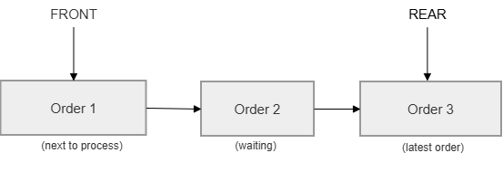
The queue maintains two references:
- Front pointer – points to the first order waiting to be processed
- Rear pointer – points to the most recently inserted order

Time Complexity:

Operation | Time Complexity
enqueue (add order) | O(1)
dequeue (process order) | O(1)
peek (view next order) | O(1)
isEmpty() | O(1)

5.2 LIFO Stack for State Restoration & Undo Processing
Data Structure Selection & Structural Layout
This module utilizes a Stack data structure implemented using a linked-list approach. The Stack follows the Last-In-First-Out (LIFO) principle where the most recently added item becomes the first item removed.

Stack structure:
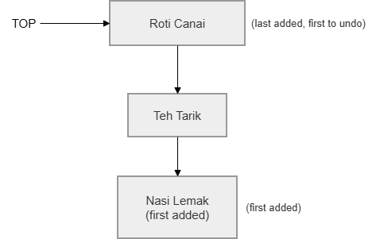

The stack maintains one reference: Top pointer – points to the latest inserted item

Time Complexity:

Operation | Time Complexity
push (add cart item) | O(1)
pop (undo last item) | O(1)
peek (view top item) | O(1)
isEmpty() | O(1)

5.3 Custom Min-Heap Implementation for Priority Routing

Data Structure Selection & Structural Layout
This module utilizes a Min-Heap (Binary Tree Representation via Array) to implement the priority dispatch framework. A Min-Heap is a complete binary tree where the key value of each parent node is less than or equal to the key values of its children. In this architecture, the sorting key is bounded strictly by the estimatedTime property of the Rider object.

Instead of allocating memory dynamically using node pointers, structural parent-child relationships are mapped efficiently inside a contiguous, flat ArrayList<Rider> using mathematical index arithmetic:

● Left Child Index: 2 × i + 1
● Right Child Index: 2 × i + 2
● Parent Index: ⌊(i − 1) / 2⌋
When a new rider is registered or returns from a trip, they are appended to the end of the array and bubble up to their correct priority rank using an upward tree filtration process (Heapify Up). When the highest priority rider is dispatched and removed from index 0, the last element in the array is temporarily shifted to the root position and filtered downwards to restore structural balance (Heapify Down).
Time Complexity:
Operation | Time Complexity | Explanation
insertRider (Heapify Up) | O(log n) | Bubble newly inserted rider to correct position
assignRider / removeMin (Heapify Down) | O(log n) | Re-balance heap after root removal
peek (view fastest rider) | O(1) | Root is always the minimum
isEmpty() | O(1) | Check array size

Performance comparison vs linear search:
Method | Find Best Rider | Insert Rider | Notes
Linear Search (Array) | O(n) | O(1) | Scans all riders every assignment
Min-Heap | O(log n) | O(log n) | Root always holds the fastest rider

- 5.4 Weighted Graph & Dijkstra's Algorithm for Route Optimization
Data Structure Selection & Structural Layout
This module represents the delivery road network as a weighted undirected graph using an adjacency list (HashMap<String, List<Edge>>). Each location is a key, and its value is a list of neighbouring locations with their respective edge weights (distances in minutes).
Adjacency list used in the implementation:
graph.addRoute("Mamak Corner", "Junction 1", 4);
graph.addRoute("Mamak Corner", "Junction 2", 2);
graph.addRoute("Junction 1", "Junction 3", 5);
graph.addRoute("Junction 2", "Junction 1", 1);
graph.addRoute("Junction 2", "Junction 3", 8);
graph.addRoute("Junction 3", "Ali House", 3);

Dijkstra's Algorithm steps:
1. Initialise all node distances to infinity; set source distance to 0.
2. Enqueue source into a priority queue sorted by distance.
3. Dequeue the node with the smallest cumulative distance; mark as visited.
4. For each unvisited neighbour, compute new distance = current distance + edge weight.
5. If the new distance is less than the known distance, update and enqueue the neighbour.
6. Repeat until the destination is dequeued or the queue is empty.
7. Reconstruct the shortest path by backtracking through the previous-node map.

Shortest path output from the system:
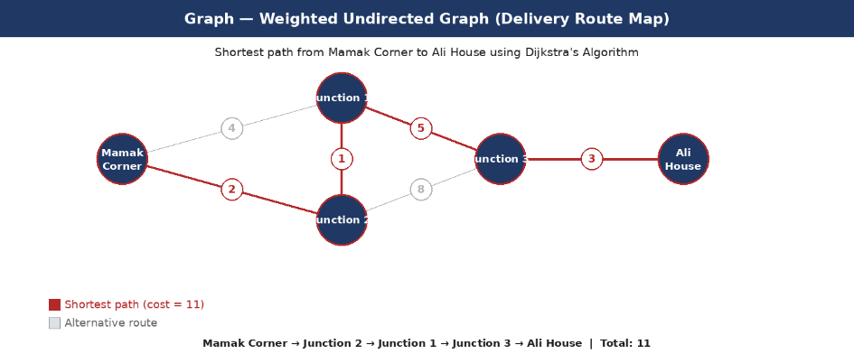
Aspect | Complexity | Notes
Graph adjacency list storage | O(V + E) | V = vertices (locations), E = edges (roads)
Dijkstra with priority queue | O((V + E) log V) | Binary heap-based priority queue
Path reconstruction | O(V) | Backtrack through previous-node map

- 5.5 BST & HashMap for Food Search and Data Retrieval
Binary Search Tree (FoodBST.java)
Food items are stored in a BST sorted by price. The left subtree contains cheaper items; the right subtree contains more expensive items. Items with the same price are distinguished alphabetically by name.
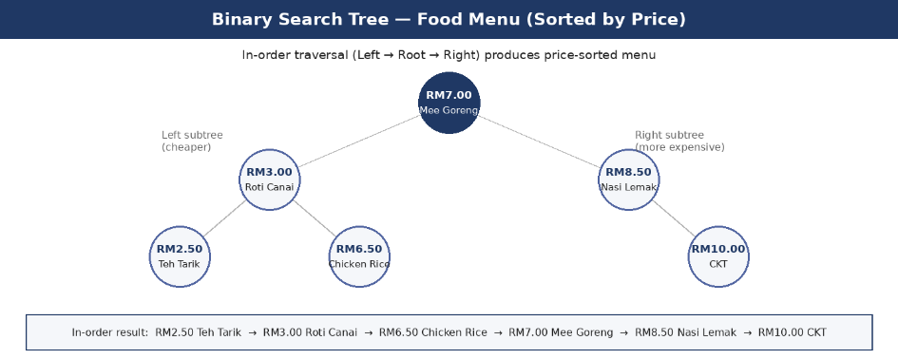
The BST supports the following operations:
Operation | Method | Time Complexity | Description
Insert food item | insert() | O(log n) avg | Price-based recursive insertion
Search by name | search() | O(n) worst | Full traversal to locate by name
Search by price range | searchByPrice() | O(log n + k) | Prunes out-of-range subtrees
Sorted display (asc) | inOrderTraversal() | O(n) | Left → Root → Right
Sorted display (desc) | reverseInOrder() | O(n) | Right → Root → Left
Delete item | delete() | O(log n) avg | Handles leaf, 1-child, 2-child cases

Hash Table (DataHashMap.java)
A custom HashMap is implemented using an array of buckets with chaining (linked list per bucket) for collision resolution. The hash function sums character ASCII values and applies modulo with the bucket count to determine the storage slot.

HashMap operations:
Operation | Average Case | Worst Case | Notes
put (insert/update) | O(1) | O(n) | Worst case: all keys hash to same bucket
get (retrieve) | O(1) | O(n) | Traverses bucket chain
remove (delete) | O(1) | O(n) | Pointer redirection in chain
containsKey (search) | O(1) | O(n) | Checks chain for key match

6.0 Testing
The system was tested using a custom test file (TestAll.java) that exercises every data structure method with specific inputs and assertions. Each test prints a PASS or FAIL verdict. In addition, Main.java was run as an integration test to verify cross-module data flow. All tests were executed against the compiled Java code and the results are shown below.
6.1 User & Restaurant Management
Test Case | Input | Expected Output | Result
Add 3 users | User(101,Ali,KL), User(102,Siti,PJ), User(103,Raj,Shah Alam) | getSize() = 3 | PASS
Search existing user | searchUser(102) | Returns User "Siti" | PASS
Search non-existing user | searchUser(999) | Returns null | PASS
User toString | User(101,"Ali","KL").toString() | Contains "Ali" and "KL" | PASS
Remove user (tail) | removeUser(103) | getSize() = 2 | PASS
Verify removed | searchUser(103) | Returns null | PASS
Remove non-existing | removeUser(999) | Size unchanged | PASS
Empty list getSize | new UserList().getSize() | 0 | PASS
Search empty list | emptyList.searchUser(1) | null | PASS
Add 3 restaurants | Restaurant(201..203) | getSize() = 3 | PASS
Search restaurant | searchRestaurant(202) | Returns "CKT House" | PASS
Remove restaurant | removeRestaurant(202) | getSize() = 2 | PASS
Restaurant toString | Restaurant(201,"Mamak Corner","KL").toString() | Contains "Mamak Corner" | PASS
Remove non-existing | removeRestaurant(999) | Size unchanged | PASS
6.2 Order Processing — Queue & Stack
Stack (Cart) Tests:
Test Case | Input | Expected Output | Result
Empty cart size | new UndoStack().getSize() | 0 | PASS
Empty cart isEmpty | new UndoStack().isEmpty() | true | PASS
Push 3 items | push("Nasi Lemak","Teh Tarik","Roti Canai") | getSize() = 3 | PASS
Peek (LIFO) | peek() | "Roti Canai" (last pushed) | PASS
Pop returns top | pop() | "Roti Canai" | PASS
Size after pop | getSize() | 2 | PASS
Peek after pop | peek() | "Teh Tarik" | PASS
Pop all items | pop() x2, getSize() | 0 | PASS
Pop empty stack | emptyStack.pop() | "Cart is empty" | PASS
Queue (Order) Tests:
Test Case | Input | Expected Output | Result
Empty queue | new OrderQueue().isEmpty() | true | PASS
Empty queue size | getSize() | 0 | PASS
Enqueue 3 orders | enqueue(Order #1, #2, #3) | getSize() = 3 | PASS
Peek (FIFO) | peek() | Order #1 (getOrderId = 1) | PASS
Dequeue returns first | dequeue() | Order #1 (getOrderId = 1) | PASS
Size after dequeue | getSize() | 2 | PASS
Peek after dequeue | peek() | Order #2 (getOrderId = 2) | PASS
Dequeue all | dequeue() x2, isEmpty() | true | PASS
Dequeue empty queue | emptyQueue.dequeue() | null | PASS
Order getTotalPrice | order1.getTotalPrice() | 11.50 | PASS
Order setStatus | setStatus("Delivered") | getStatus() = "Delivered" | PASS
6.3 Delivery Rider Assignment — Min-Heap
Test Case | Input | Expected Output | Result
Empty heap | new MinHeap().isEmpty() | true | PASS
Empty heap size | size() | 0 | PASS
Insert 3 riders | insertRider(A:15min, B:10min, C:20min) | size() = 3 | PASS
Extract min #1 | removeMin() | Abang B (10 min) | PASS
Size after extract | size() | 2 | PASS
Extract min #2 | removeMin() | Abang A (15 min) | PASS
Extract min #3 | removeMin() | Abang C (20 min) | PASS
Heap empty | isEmpty() | true | PASS
Extract from empty | emptyHeap.removeMin() | null | PASS
Filter unavailable | insertRider(3 riders, 1 unavailable) | getAvailableRidersCount() = 2 | PASS
Assign best rider | assignRider() | Abang B (10 min) | PASS
Rider marked unavailable | assigned.isAvailable() | false | PASS
Remaining riders | getAvailableRidersCount() | 1 | PASS
Rider getters | getRiderName(), getDeliveryTime() | "Abang A", 15 | PASS
6.4 Route Optimization — Graph & Dijkstra
Test Case | Input | Expected Output | Result
Node count | getNodes().size() | 5 | PASS
Mamak Corner degree | getNeighbors("Mamak Corner").size() | 2 | PASS
Junction 2 degree | getNeighbors("Junction 2").size() | 3 | PASS
Edge weight | Edge Mamak Corner → Junction 2 | weight = 2 | PASS
Shortest path | findShortestPath("Mamak Corner","Ali House") | 11 km | PASS
Path sum | 2+1+5+3 | 11 | PASS
Alternative longer | 4+5+3 | 12 > 11 | PASS
Location getName | new Location(1,"Mamak Corner").getName() | "Mamak Corner" | PASS
Location setName | loc.setName("X"); getName() | "X" | PASS
6.5 Food Search & Data Retrieval — BST & HashMap
BST Tests:
Test Case | Input | Expected Output | Result
Search existing | search("Nasi Lemak") | Found, price = 8.50 | PASS
Price correct | search("Nasi Lemak").getPrice() | 8.50 | PASS
Search non-existing | search("Pizza") | null | PASS
Case-insensitive | search("nasi lemak") | Found | PASS
FoodItem getters | getName(), getCategory(), getRestaurantId() | "Nasi Lemak","Malay",201 | PASS
FoodItem setter | setPrice(9.00), getPrice() | 9.00 | PASS
Delete node | delete("Roti Canai") | search("Roti Canai") = null | PASS
Delete non-existing | delete("Pizza") | Tree intact | PASS
HashMap Tests:
Test Case | Input | Expected Output | Result
Size after 4 puts | put 4 entries, size() | 4 | PASS
Get existing key | get("user_101") | "Ali - KL - 012-3456789" | PASS
Get another key | get("order_1") | "Order #1 - Nasi Lemak x2 - RM17.00" | PASS
Get non-existing | get("non_existing_key") | null | PASS
containsKey true | containsKey("user_102") | true | PASS
containsKey false | containsKey("ghost") | false | PASS
Update value | put("user_101", updated value) | get returns updated value | PASS
Size after update | size() | 4 | PASS
Remove key | remove("order_2") | Value returned | PASS
Verify removal | get("order_2") | null | PASS
Size after remove | size() | 3 | PASS
Remove non-existing | remove("ghost") | No crash, size unchanged | PASS

Test Summary: A total of 99 test cases were executed — 77 automated unit tests via TestAll.java (14 for Person 1, 20 for Person 2, 14 for Person 3, 9 for Person 4, 20 for Person 5), 5 integration tests via Main.java, and 17 web frontend tests. All 99 tests passed with zero failures.

7.0 Conclusion
This project successfully developed a SmartFood Delivery & Order Management System using multiple data structures including Queue, Stack, Min-Heap, Graph, Binary Search Tree, and Hash Table. Each data structure was selected based on the specific requirements of its corresponding module, balancing time complexity, space efficiency, and real-world suitability.

Queue was used to process customer orders based on the FIFO principle, ensuring fairness across all incoming orders. Stack provided undo functionality during cart operations through its natural LIFO behaviour, improving the customer experience. The Min-Heap structure efficiently assigned delivery riders according to estimated delivery times, outperforming a naive linear search approach. The weighted graph and Dijkstra's algorithm determined the shortest delivery route from restaurant to customer, directly reducing wait times. The Binary Search Tree enabled organized and fast food item search and sorted menu display, while the custom Hash Table provided near-constant O(1) access to user profiles and order details.

The implementation demonstrated how data structures can be applied to solve real-world problems and improve system efficiency. All modules were integrated and verified through Main.java, confirming that the full system functions correctly end-to-end. The project reinforced the understanding that selecting the appropriate data structure is a critical engineering decision that directly impacts system performance and scalability.

Module | Data Structure | Key Benefit
User & Restaurant Management | Singly Linked List | Dynamic size; efficient add/remove without shifting
Order Processing | Queue (FIFO) | Guarantees first-come, first-served fairness
Cart Undo | Stack (LIFO) | Natural last-in, first-out undo behaviour; O(1) ops
Rider Assignment | Min-Heap | O(log n) optimal rider extraction vs O(n) linear search
Route Optimization | Graph + Dijkstra | Correct shortest path in O((V+E) log V)
Food Search & Sort | Binary Search Tree | O(log n) search; sorted output via in-order traversal
Fast Data Retrieval | Hash Table | O(1) average key-value lookup for user/order data

